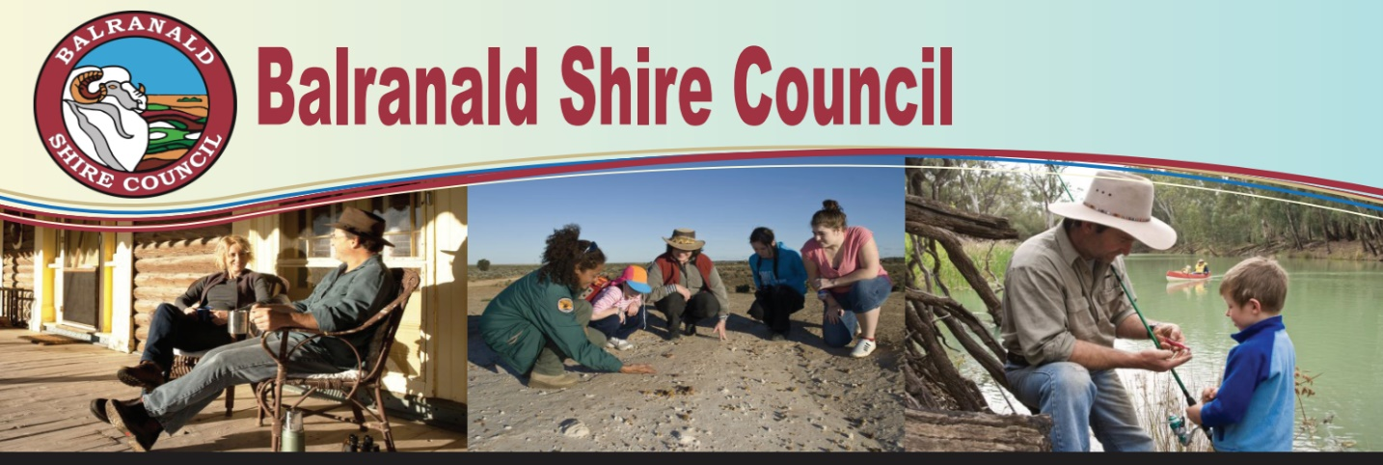

Home to the ‘Five Rivers’, the Balranald Shire offers a unique lifestyle where water sport lovers are spoilt for choice and hikers and campers have the wonders of Mungo National Park at their doorstep. Steeped in history and with easy access to the regional hubs of Swan Hill, Mildura and Griffith, Balranald Shire is a place where the community is front of mind and the Council is committed to the Shire’s long-term future.

An exciting opportunity exists for a skilled and motivated individual to work in a team environment as:

**EXECUTIVE MANAGER: COMMUNITY & GOVERNANCE**

**Attractive Salary Package up to $218,804, plus Superannuation, Motor Vehicle & Housing**

As a member of the Executive Leadership Team, to provide ongoing high-level leadership, strategic direction, management and coordination of the Community & Governance Department to ensure delivery of the Department’s key objectives and the provision of high-quality services to the Balranald community.

Some Key Accountabilities are:

1. Effective leadership and management of the Department including the following functional areas: Governance, Communications, Bidgee Haven Retirement Hostel, Human Resources & WH&S, Risk Management, Customer Service, Community Services, Tourism and Business Development Services; Caravan Park; and Corporate Planning (IP&R)
2. Ensure Department compliance with all statutory requirements as prescribed by the Local Government Act 1993, relevant State and Federal legislation and Council policies and procedures.
3. Develop strategies, policies and procedures to ensure effective planning, implementation and monitoring of all programs and services within the Department.

Excellent written and verbal communications skills, strong computer literacy and the ability to work as part of a close knit and collaborative team is essential.

Some of our great benefits include a 9-day fortnight, 12% Superannuation, 15 days’ sick leave per year, long service leave after 5 years, ongoing learning and development opportunities and an employee assistance program.

Terms of employment will be in accordance with the NSW Local Government (State) Award 2023 and Councils salary and performance management systems.

The position description is available at [www.balranald.nsw.gov.au](http://www.balranald.nsw.gov.au) or contact the Human Resources Officer on (03) 50201300 or [hr@balranald.nsw.gov.au](mailto:hr@balranald.nsw.gov.au)

**Applications close: Friday 20th June 2025 at 5pm and should be addressed to the Interim General Manager, via email to** [hr@balranald.nsw.gov.au](mailto:hr@balranald.nsw.gov.au)

Peter Bascomb

**Interim General Manager**