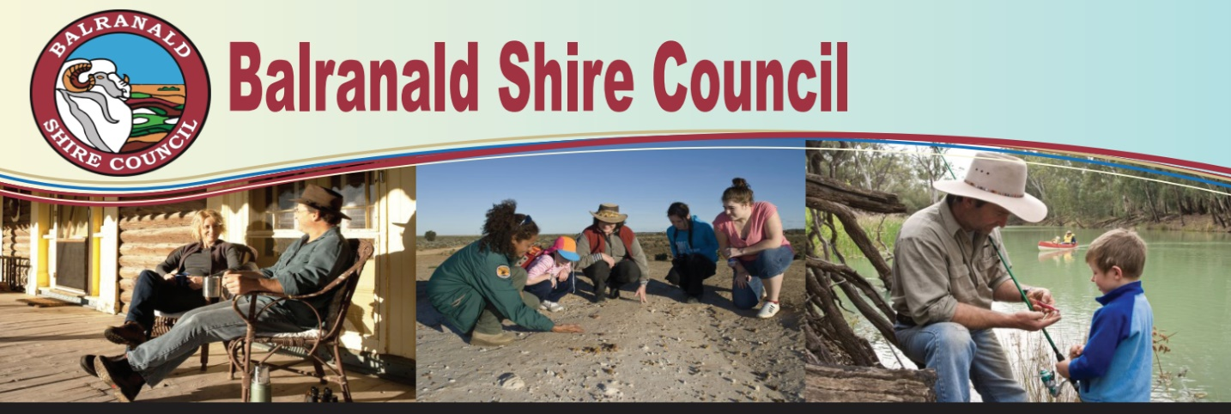

Balranald Shire Council are thrilled to announce we have been granted provisional approval funding to employ multiple Trainees and Apprentices under the NSW Governments “Fresh Start Program”.

The Fresh Start program enables students and school leavers to study and learn on the job while gaining a nationally accredited qualification.

An exciting opportunity exists for a motivated individual as part of the ‘Fresh Start Program’ as a:

**HUMAN RESOURCES TRAINEE**

**Salary will be from $482 up to $947.70 per week depending on age and qualifications.**

The HR Trainee will assist the HR Officer with all aspects of managing employees’ lifecycle. Including recruitment, selection, onboarding, training and other duties associated with employee wellbeing.

Over the course of the traineeship the incumbent will develop and apply the skills and competencies acquired to be a highly effective HR team member. The trainee will complete a Certificate IV in Human Resources throughout the 2-year term of the contract.

Some Key Accountabilities are:

1. Perform all general administration functions (phone, letters, filing) and assist with the maintenance of all HR systems including information systems and electronic records.
2. Assist users with basic HR issues gradually increasing this assistance as skills and knowledge increase.
3. Gradually build a sound knowledge of the Local Government (State) Award, Council HR policy, Work Health & Safety, and all other relevant legislation.

Terms of employment will be in accordance with the NSW Local Government (State) Award 2023 and Councils salary and performance management systems.

The position description is available at [www.balranald.nsw.gov.au](http://www.balranald.nsw.gov.au) or contact the Human Resources Officer on (03) 50201300 or [hr@balranald.nsw.gov.au](mailto:hr@balranald.nsw.gov.au)

**Applications, including Letter & Resume close: Thursday 31st July 2025 at 5pm and should be addressed to the Interim General Manager, via email to** [hr@balranald.nsw.gov.au](mailto:hr@balranald.nsw.gov.au)

Peter Bascomb

**Interim General Manager**

