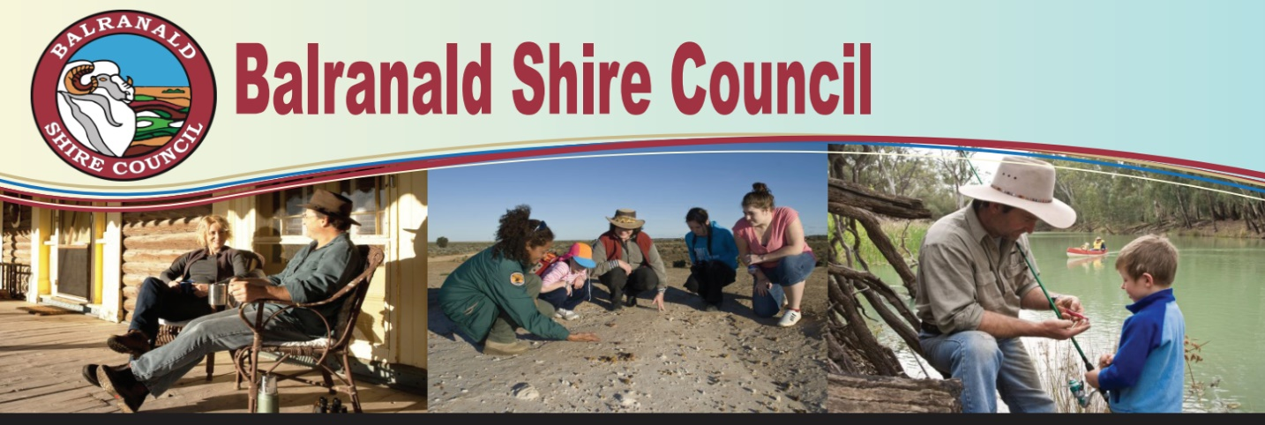

Balranald Shire Council are thrilled to announce we have been granted provisional approval funding to employ multiple Trainees and Apprentices under the NSW Governments “Fresh Start Program”.

The Fresh Start program enables students and school leavers to study and learn on the job while gaining a nationally accredited qualification.

An exciting opportunity exists for a motivated individual as part of the ‘Fresh Start Program’ as a:

**WORK HEALTH & SAFETY TRAINEE**

**Salary will be from $482 up to $947.70 per week depending on age and qualifications.**

The Work Health & Safety (WHS) Trainee will assist the WHS & Risk Officer and Human Resources team with all aspects of managing employees’ safety & wellbeing. Including induction, onboarding, training, work cover injury management and other duties associated with employee wellbeing.

Over the course of the traineeship the incumbent will develop and apply the skills and competencies acquired to be a highly effective WHS Officer. The trainee will complete a Certificate 111 in Work Health & Safety throughout the 2-year term of the contract.

Some Key Accountabilities are:

1. Perform all general administration functions (phone, letters, filing) and assist with basic WHS & Risk issues gradually increasing this assistance as skills and knowledge increase.
2. Assist with the maintenance of all WHS & Risk systems including information systems and electronic records.
3. Gradually build a sound knowledge of the Local Government (State) Award, Council HR policy, Work Health & Safety, and all other relevant legislation.

Terms of employment will be in accordance with the NSW Local Government (State) Award 2023 and Councils salary and performance management systems.

The position description is available at [www.balranald.nsw.gov.au](http://www.balranald.nsw.gov.au) or contact the Human Resources Officer on (03) 50201300 or [hr@balranald.nsw.gov.au](mailto:hr@balranald.nsw.gov.au)

**Applications, including Letter & Resume close: Thursday 31st July 2025 at 5pm and should be addressed to the Interim General Manager, via email to** [hr@balranald.nsw.gov.au](mailto:hr@balranald.nsw.gov.au)

Peter Bascomb

**Interim General Manager**

